**network graph:**

vertex/node: each entity

edge/line/arc: connection

* undirected/directed
* weighted

degree:

* the number of edges connected to a vertex
* the size of the vertex’s neighbourhood

**statistics of network as a whole:**

* diameter: the longest distance (geodesic) between any two vertices
* average path length: average distance between any two vertices over the whole network
* degree distribution: the probability distribution describing the magnitude of vertices in the network
* density: proportion of edge numbers/maximum number possible

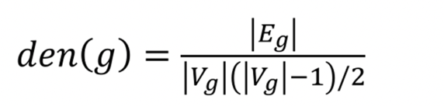

|Eg|: number of edges

|Vg|: number of vertices

* clustering coefficient: triangles/connected triples
* 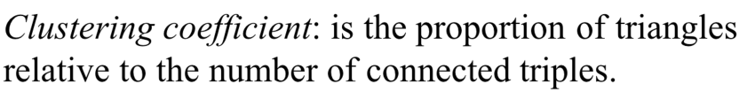

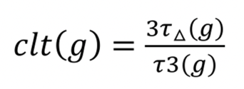Top number of triangles, bottom is number of triples

**Example:**

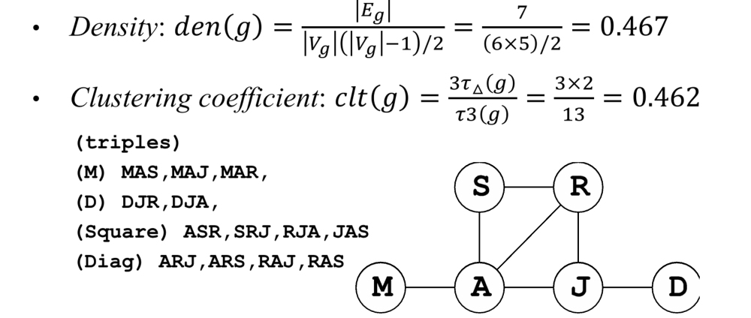

**importance of a vertex:**

* degree
* centrality
  + betweenness: hub potential of a node
  + closeness: how well a node is connected locally
  + eigenvector: weigh a node according to the quality of its connections

betweenness:

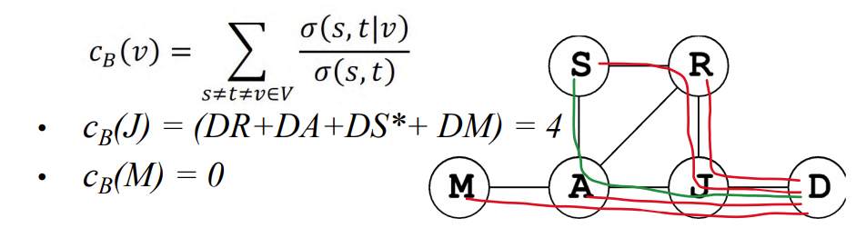

* numerator: total number of shortest paths between node s & t that passes through v
* denominator: total number of shortest paths between node s & t

closeness:

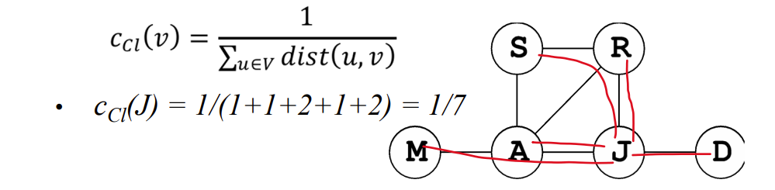

denominator: total distance (shortest path) between a vertex and the others

